Campaign Marketing Plan

Campaign snapshot
Campaign | Perth Is Dead  Rationale: Christmas is over, and everyone else has headed d’outh or overseas. The summer festival season has started yet. Dark Stry’s Perth murder-and-macabre tour is the best thing to do during the ‘space in between’.
Campaign goals | Short, sharp campaign focused primarily on intrastate tourists looking for ‘last minute’ things to do before they must head back to work.
Why Dark Stry / Murder & Macabre tour? | - Something new – do it before your friends do  - See what happened where – experience true crime, don’t just watch the TV show or read the book so that you can work out your escape route  - Works for all budgets  - Over-gifted? – jump on public transport or enjoy City of Perth’s free Christmas parking; bring a picnic to enjoy in Supreme Court gardens  - Treat yo’ self? - go luxe on a Peddle Perth rickshaw and enjoy cocktails at the City’s best bars
Campaign target audience | - Journalists / earned media looking for unique, engaging content over their quiet period  - FOMO – Intrastate tourist regularly comes into the City, wants something new & different and wishing they were down south with everyone else. Get cultural before Perth Festival starts.  - True crime tragic – intrastate tourist rarely comes into the City and needs a special push to get off the couch and do something IRL (in real life)  - ‘Stuck’ in the City at Christmas – interstate tourist already in the CBD and confused as to why everyone in Perth just died / came to a grinding halt
Audience insights | - True crime strongly skews female 24-55  - Most women are interested in true crime as empowerment – exploring true crime stories makes them feel like they would know how to respond in a dangerous situation
CTA | - Buy ticket first & then download the app  - Peddle Perth: ask Zac & add here

Key dates
Before 19th Dec | Plan – scheduling & stakeholder engagement
19th Dec to 26th Dec | Engage with us – create conversations about Perth Is Dead via social media filters & earned media
27th Dec to 2nd Jan | Explore with us – buy your access code and get out there
January | Extend campaign across tourism industry channels  Note: will only run paid ads over January if get decent conversion from initial spend

Route snapshot
Route title | Perth CBD Murder & Macabre
Route description (as appears in app) | Humankind has been obsessed has been telling stories about crime and misadventure since the printing press was created.  Dark Stry takes true crime to Perth's streets - no longer a guilty pleasure to be enjoyed behind closed doors. Our app doesn't just tell you, it shows you, the things that go bump in the night.  Each stop on this self-guided tour is paired with a different bar or restaurant so that you can keep hydrated on your adventure into Perth's darker side.
Route partners | N/a
Route publication date | Already published
Route length | 2 hours / 2 kms / 7 stops
Route start location | King St, Perth  Closest PT: Perth Busport / Perth Train Station
Route end location | Barrack Square, Perth  Closest PT: Barrack Square, Perth (Elizabeth Quay Train Station)
Route stories | 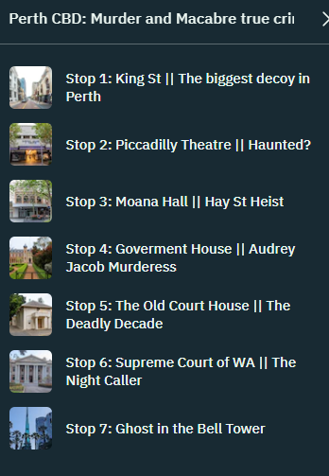
Route price | $25 RRP  (EC note: I will create some kind of discount for friends offer – need to confirm logistics using Shoprocket)
Route target audience (outside of campaign period) | True crime fans – intrastate and interstate

Route info
Banner colour | Pink - #F8B5BA
Route banner | 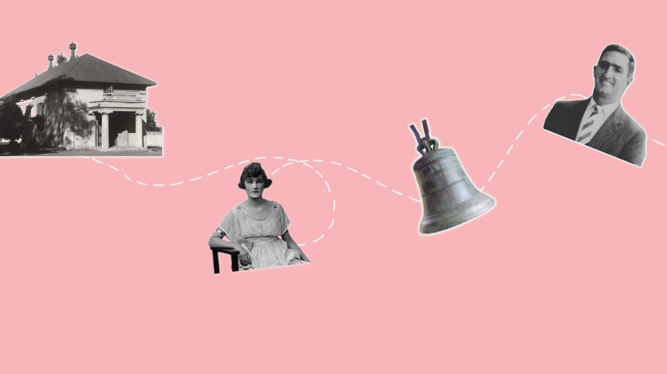
Suggested route hero images | - Old Courthouse / Law Museum  - Piccadilly Theatre – anything to make it look haunted  - Audrey Jacobs - murder on the dancefloor  - Murder on the dancefloor audio – song that was playing when Audrey shot Cecil  - Eric Edgar Cook – Australia’s worst serial killer. Note that recent interest in his story due to Stan documentary series.  All hero images are available from Dark Stry SharePoint here.
Preview | https://darkstry.stqry.app/2/tour/16516  Code: test22 (not case sensitive)

Social media mentions
Suggestions for mentions to be used on social media to expand engagement:
- Venues – venues featured on the route to be included where relevant
- Performers – please make sure that any images featuring performers are tagged with Tease Industries and the relevant performer’s account (Jess to provide)
- Audrey Jacob / Murder on the Dancefloor – Fremantle Press & Leigh Straw always happy to support what we are doing. Leigh only just released her latest book on this >> https://fremantlepress.com.au/books/the-ballroom-murder/
- Indoor photos – these were taken with Spaces The Wentworth as a backdrop - https://www.spacesworks.com/. The Wentworth was formerly owned by Mary Raine, who is featured on our Enterprising Women tour.
- King St decoy – all images should be tagged with Varnish on King. Erin needs to follow up with them re. linkages to their NYE event.
- Old Law Court Museum – shown on our route header. Their recent exhibition was the inspiration behind the ‘the Deadly Decade’ content/stop. They are/were also running a campaign about justice/John Button, which has a relationship to the Eric Edgar Cooke stop.

Campaign key messages
Potential tag lines / conversation starters
- Perth is dead
- Always have an escape plan
- Perth: the serial killer capital of Australia

Media: what makes it newsworthy for media?
- Eye catching images and videos – recreation of iconic true crime events at some of Perth’s most iconic tourist locations
- True crime factoids – humans have been fascinated with true crime since the time of the printing press. Tell the behind-the-scenes tales for iconic places like the Bell Tower and Piccadilly Theatre.
- Fun filters - celebrating the intersection of arts, history and technology with social media inspired by Perth’s history. Perth is becoming a creative industries hub
- Collaborative homegrown success story – We’ve working with Perth-grown artists like Tease Industries and tourism icons like Peddle Perth to showcase the best Perth has to offer, with our routes showcasing hospitality venues across the City. Dark Stry’s is led by a female co-founder using emerging technologies to tell uniquely West Australian stories.

Tourism networks: what makes it relevant for tourism promotion groups?
- Unique: mixes history, arts and technology with the stunning backdrop of some of Perth’s most iconic locations
- Collaborative: finishes at the Bell Tower, collaboration with Peddle Perth
- Content: mix of different artefacts to choose from

Target customers: social media
Elysse – heads up the wording below is just indicative and needs a good polish before publishing to match voice for target market (true crime fans / ladies who ros$\grave{e}$).
- Now to 19th Dec: Follow us
  - Key message 1: Perth is dead – there’s lots to do. See what happened, where.
  - Key message 2 (true crime fans): Always have an escape plan. Western Australia is the serial killer capital of Australia. Learn about the ones that got away.
  - Noting that we’ll be using our LinkedIn to run the Start Up for Christmas campaign
- 19th Dec to 26th Jan: Engage with us
  - Channel your inner murderess with our social media filters (free for facebook and Instagram users). Tag your friends who you want to do a true crime tour with.
- 27th Dec to 2rd Jan: Explore with us
  - Always have an escape plan – Stop scrolling on the couch and doing something fun with your time off. Purchase your adventure
  - Create FOMO - share your Dark Stry adventure with your friends on social media. Get the vibe with our social filters.
  - See history differently – (note: this message is more for intrastate visitors already in the CBD that will be picked up by A3 & card campaign)

Available collateral
What | Key Contact | Audience | Status | Location
Avant Card design | Aron | Stuck in the CBD at Christmas | Complete | EC to upload to Wix
A3 poster design | Aron | Stuck in the CBD at Christmas | Complete | EC to upload to Wix
Piccadilly Theatre Ghost | Aron | True crime fans | Complete | EC to upload to Wix
Route promo animation | Aron | FOMO | Complete | EC to upload to Wix
Social Filter 1 – inspired by bloody bride / haunted Swan River bells | Natalie | FOMO | Awaiting EC final feedback | Natalie to push to PROD
Social Filter 2 – inspired by “murderess” Audrey Jacobs incl. OG music | Natalie | FOMO | Awaiting EC final feedback | Natalie to push to PROD
Social Filter 3 – inspired by King St Decoy, female crime gangs | Natalie | FOMO | Awaiting EC final feedback | Natalie to push to PROD
Previews of each of the social filters / artwork that could be shared | Natalie | Media | EC to ask Natalie if she’s got something EC can share with media to reference
Tease Industries images & video – links to:  - Audrey Jacob – murderess on the dancefloor  - Ghost at the Bell Tower – bloody bride  - King St decoy – female crime gangs  Note: Jess is going to provide the raw images so please hunt through & see what you want to use @Elysse | Jess | FOMO | Jess to provide raw images no later than 18th (photoshoot 11th)
Route QR code – used on printed materials to track engagement | Erin | Stuck in the CBD at Christmas |  | EC to fix link so that it goes to Shoprocket rather than the app store!!!  EC to upload QR code to Wix
Press release | Amanda | Media | EC drafted – Amanda to edit if she’s got time

Key activities
Deliverable | Materials | Audience | Key messages | Who | When | Comments
Media Kit w/ 1 page press release | Uploaded to Wix including all photos & videos | Perth media | As outlined in key messages | Erin | EMBARGO for 19th Dec | Target to send on 15th if Jess has time to get the photos edited
Linktree / Instagram | Shoprocket – direct link to tour purchase (EC to add) | FOMO  Truecrime fans | Buy a tour access code here – it’s easy to use | Elysee | Before 19th Dec | @Elysse – can something be done with FB so that it links to Shoprocket rather than the website for better conversion?
Facebook & Instagram social posts | Re-purpose anything that floats your boat, with a focus on the content from Tease Industries and the AR filters from Natalie | FOMO  Truecrime fans | As per key dates | Elysse | Scheduled as per key dates
Facebook & Instagram ad campaign – attract followers | Elysse’s choice using any of the materials provided | FOMO  Truecrime fans | $150 / week spend | Elysse | Before 19th Dec | Lower priority – focus is on the below & the social posts for Christmas/NYE period
Facebook & Instagram ad campaign – Conversion goal | A/B test – animation provided by Aron and carousel of images/short videos from Tease Industries | FOMO  Truecrime fans | $1,000 spend from 27th to 2nd, pull if no conversion | Elysse | Before 27th Dec | Highest priority
Outdoor/café A3 & Avant Ca posters | Printed materials designed by Aron & printed by 3rd party | Anyone in the CBD | Perth Is Dead | Leonie | Distribution from 12th Dec; finished by 21st Dec | Many venues will be closed during this period – expect channels coming from these well into January
Wix buy now pop-up |  | Anyone buying | Get your code now | Erin | Before 19th Dec
Wix collateral page – expand for route specific content | Everything in the collateral section | Media & special interest groups | We’ve got all of the content you need | Erin
Perth Tourism Council WA | EC to follow up with them |  |  | Erin
Destination Perth – January Give Away |  |  |  | Erin | Follow up in early Jan
Destination Perth – EDM |  |  |  | Erin | Follow up in early Jan
Perth Visitor Centre drop-in | Avant cards & A3 posters  Donuts | Intrastate tourists |  | Erin | Anytime I can | See if I can get hold of Corey again?
Perth ‘listicles’ | TBA | FOMO |  | Erin |  | EC needs to follow up around this ASAP

